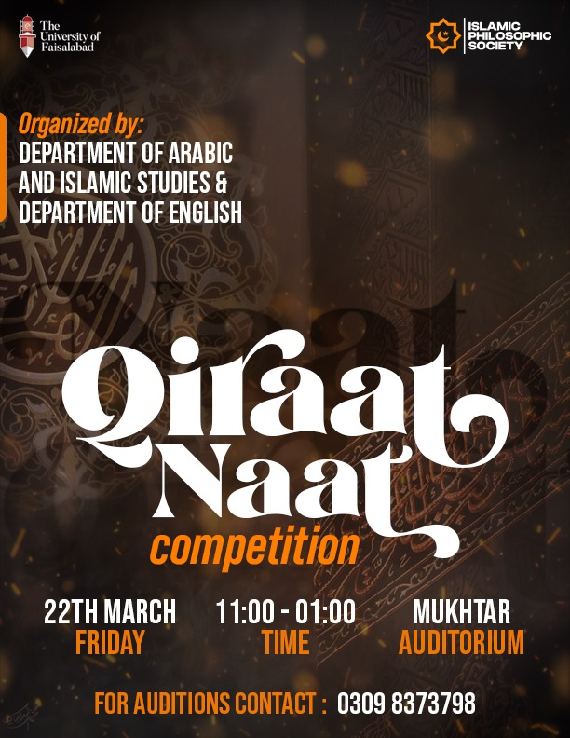
The Department of English Language and Literature in Collaboration
with the department of Islamic studies , organized Naat and Qirat
competitions following the true spirit of Ramazan Calendar planted by
the competent authorities.
The renowned religious personalities Qari Deen Muhammad and Mr. Sjid
Ali Sajid graced the event with their mesmerizing recitation of The
Holy Quran and the Naat-e- Rasool respectively.
The position holders of both categories were awarded with
certificates. Afterwards
Dr. Matloob, Dean of Social Sciences thanked the guests and concluded
the event with Dua.

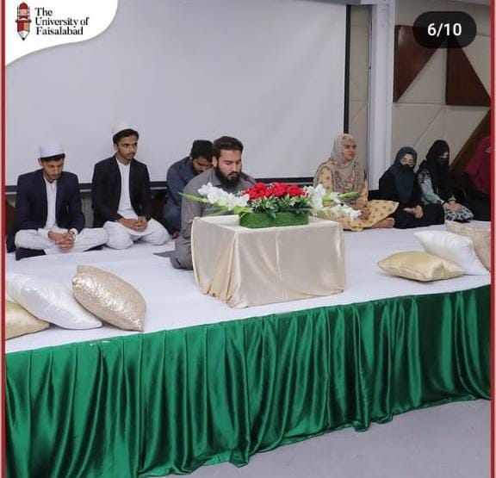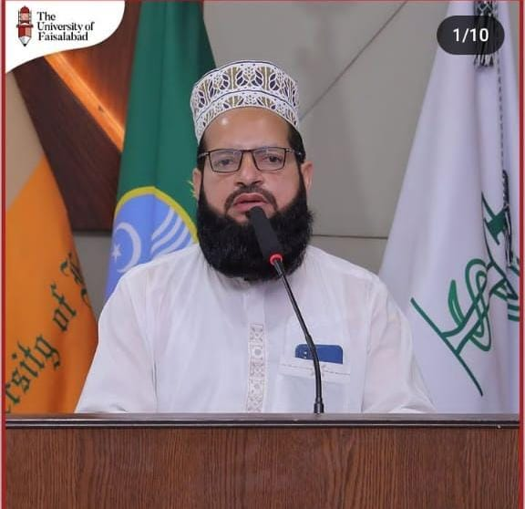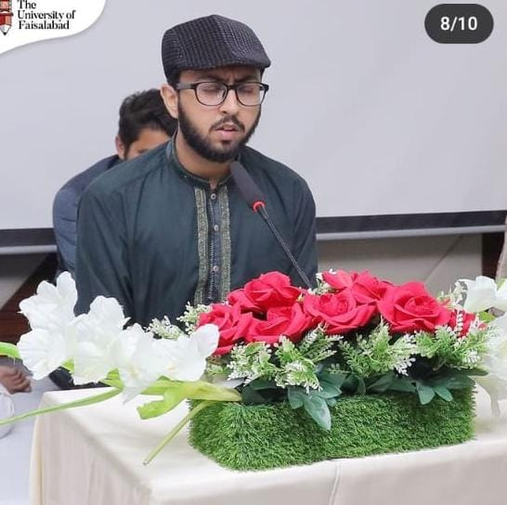
Report on Naat and Qirat Competition
The Department of English Language and Literature in Collaboration with the department of Islamic studies, organized Naat and Qirat competitions following the true spirit of Ramadan Calendar planned by the competent authorities.
The event was orgnazied at Mukhtar Auditoriam on Friday 22ndMarch, 2024. The renowned religious personalities Qari Deen Muhammad and Mr. Sajid Ali Sajid graced the event with their mesmerizing recitation of The Holy Quran and the Naat-e- Rasool Maqbool respectively.
The students from different disciplines participated in the competitions. Dr.Matloob Ahmad, HoD of Islamic Studies instructed the participants about the rules of Naat and Qirat competition.
The Jury panel for Qirat Competition
- Qari Deen Muhammad from Jamia Qadria Rizvia Faisalabad

- Dr. Hifsa Munawar Assistant Professor Islamic Studies
Winners of Qirat Competition
S# | Name | Registration | Department | Position
1 | Mohsin Imtiaz | 2023-bs-se-064 | BSSE (II) | 1st
2 | Muhammad Wahaj |  | BSAI (II) | 2nd
3 | Muhammad Umair | 2023-d-pharm-5126 | DPH (II) | 3rd
The Jury panel for Naat Competition
- Sajid Ali Sajid from 92 NEWS
- Dr. Qasim Shafiq HoD English Language and Literature
Winners of Naat Competition
S# | Name | Registration | Department | Position
1 | Urooj Fatima | 2023-DPT-140 | DPT (II) | 1ST
2 | Hasnain Ahmad |  |  | 2nd
3 | Bareeha Fatima |  | DPT (I) | 3rd

The position holders of both categories were awarded with certificates. At the end Dr. Matloob, Dean of Social Sciences thanked the guests and concluded the event wit

